Ques1: Write a program to create interface named test. In this interface the member function is square. Implement this interface in arithmetic class. Create one new class called ToTestInt. In this class use the object of arithmetic class.

Source Code

**package** Lab6;

**interface** Test{

**int** square(**int** n);

}

**class** Arithmetic **implements** Test{

**public** **int** square(**int** n) {

**return** n*n;

}

}

**class** ToTestInt{

**public** **static** **void** main(String args[]) {

System.***out***.println("Hitendra Sisodia");

System.***out***.println("500091910");

Arithmetic ob = **new** Arithmetic();

System.***out***.println(ob.square(10));

}

}

Output

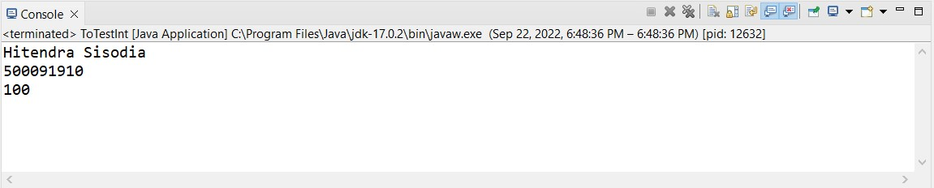

Ques2: Write a program to create interface A, in this interface we have two method meth1 and meth2. Implements this interface in another class named MyClass.

Source Code

**package** Lab6;

**interface** A{

**void** meth1();

**void** meth2();

}

**class** Mclass **implements** A{

**public** **void** meth1() {

System.***out***.println("This is Method1");

}

**public** **void** meth2() {

System.***out***.println("This is Method2");

}

}

**public** **class** MyClass {

**public** **static** **void** main(String args[]) {

System.***out***.println("Hitendra Sisodia");

System.***out***.println("500091910");

Mclass ob = **new** Mclass();

ob.meth1();

ob.meth2();

}

}

Output

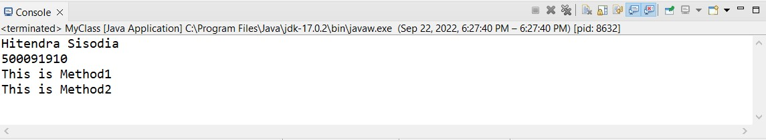

Ques3: Write a program in Java to show the usefulness of Interfaces as a place to keep constant value of the program.

Source Code

**package** Lab6;

**import** java.util.Random;

**interface** SharedConstants{

**int** ***NO*** = 0;

**int** ***YES*** = 1;

**int** ***MAYBE*** = 2;

**int** ***LATER*** = 3;

**int** ***SOON*** = 4;

**int** ***NEVER*** = 5;

}

**class** Question **implements** SharedConstants{

Random rand = **new** Random();

**int** ask() {

**int** prob = (**int**)(100 * rand.nextDouble());

System.***out***.print(prob+" ");

**if**(prob < 30) {

**return** ***NO***;

}

**else** **if**(prob < 60) {

**return** ***YES***;

}

**else** **if**(prob < 75) {

**return** ***LATER***;

}

**else** **if**(prob < 98) {

**return** ***SOON***;

}

**else** {

**return** ***NEVER***;

}

}

}

**public** **class** AskMe **implements** SharedConstants{

**static** **void** answer(**int** result) {

System.***out***.print(" "+result+" ");

**switch**(result) {

**case** ***NO***:

System.***out***.println("No");

**break**;

**case** ***YES***:

System.***out***.println("Yes");

**break**;

**case** ***MAYBE***:

System.***out***.println("Maybe");

**break**;

**case** ***SOON***:

System.***out***.println("Soon");

**break**;

**case** ***NEVER***:

System.***out***.println("Never");

**break**;

}

}

**public** **static** **void** main(String args[]) {

System.***out***.println("Hitendra Sisodia");

System.***out***.println("500091910");

Question q = **new** Question();

*answer*(q.ask());

*answer*(q.ask());

*answer*(q.ask());

*answer*(q.ask());

}

}

Output

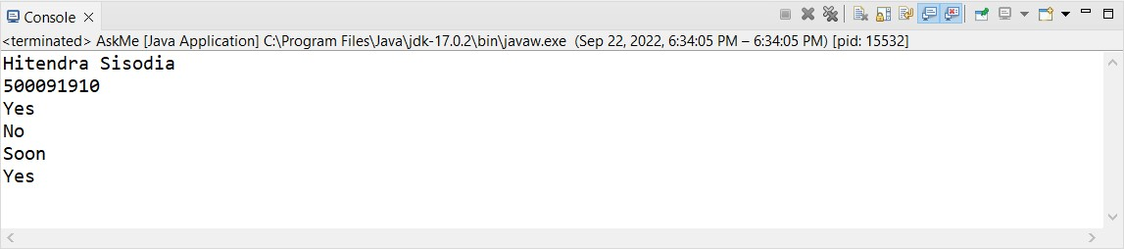

Ques4: Write a program to create an Interface having two methods division and modules. Create a class, which overrides these methods.

Source Code

**package** Lab6;

**interface** interface1{

**void** division(**int** n1,**int** n2);

**void** modules(**int** n1,**int** n2);

}

**class** SampleClass **implements** interface1{

@Override

**public** **void** division(**int** n1,**int** n2) {

System.***out***.println(n1+" / "+n2+": "+(n1/n2));

}

@Override

**public** **void** modules(**int** n1,**int** n2) {

System.***out***.println(n1+" % "+n2+": "+(n1%n2));

}

}

**public** **class** OverrideInterface {

**public** **static** **void** main(String args[]) {

System.***out***.println("Hitendra Sisodia");

System.***out***.println("500091910");

SampleClass obj = **new** SampleClass();

obj.division(36,2);

obj.modules(23, 4);

}

}

Output

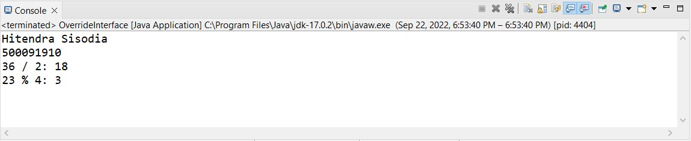

Ques4: Write program to create an interface StackInterface having methods push (), pop () and display (). StackClass implements StackInterface. Class StackClass contains the main method which is having a switch case for selecting the particular operation of the stack.

Source Code

**package** Lab6;

**import** java.util.*;

**interface** StackInterface{

**void** push(**int** n);

**int** pop();

**void** display();

}

**class** StackClass **implements** StackInterface{

**int** arr[] = **new** **int**[5];

**int** top = -1;

**public** **void** push(**int** n) {

**if**(top >= arr.length) {

System.***out***.println("Stack OverFlow");

}

**else** {

top++;

arr[top] = n;

}

}

**public** **int** pop(){

**int** temp = arr[top];

**if**(top < 0) {

System.***out***.println("Satck UnderFlow");

}

**else** {

top--;

}

**return** temp;

}

**public** **void** display() {

**if**(top == -1) {

System.***out***.println("Stack is Empty");

}

**else** {

**for**(**int** i = 0 ; i <= top ; i++) {

System.***out***.print(arr[i]+" ");

}

System.***out***.println();

}

}

**public** **static** **void** main(String args[]) {

System.***out***.println("Hitendra Sisodia");

System.***out***.println("500091910");

Scanner sc = **new** Scanner(System.***in***);

StackClass obj = **new** StackClass();

Boolean bool = **true**;

**while**(bool) {

System.***out***.print("Press 1 for pushing into stack, ");

System.***out***.print("Press 2 for pop from stack, ");

System.***out***.print("Press 3 for display, ");

System.***out***.print("Press 4 for Exit ");

**int** n = sc.nextInt();

**switch**(n)

{

**case** 1:

System.***out***.print("Enter a num to push in stack: ");

**int** num = sc.nextInt();

obj.push(num);

**break**;

**case** 2:

System.***out***.println("Pop item is: "+obj.pop());

**break**;

**case** 3:

obj.display();

**break**;

**case** 4:

bool = **false**;

**break**;

**default**:

System.***out***.println("Choose Valid Option");

}

}

}

}

Output

